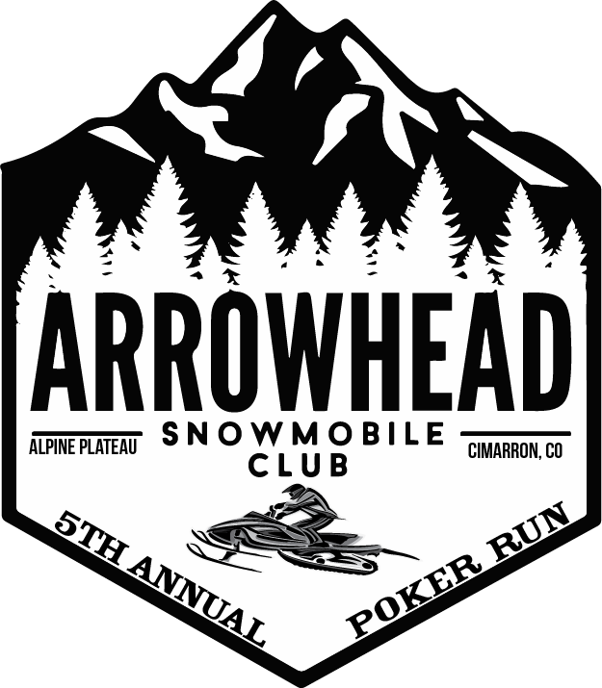
Arrowhead Snowmobile Club
21401 Alpine Plateau Rd
Cimarron, CO 81220

Dear Sir or Madam:

This letter is a request for your company’s sponsorship for the 5th Annual 2019 Arrowhead Snowmobile poker run. This event will be held on February 9, 2019 in Cimarron, Colorado and is a fundraiser for the Arrowhead Snowmobile Club (ASC). ASC is a member of the Colorado Snowmobile Association. The non-profit purpose of the CSA is to ensure safety and conservation in motorized winter recreation. The CSA is passionate about its mission to Advance, Protect and Preserve the sport of snowmobiling in Colorado.

I would like to share a few quick facts about snowmobiling:
-There are over 1.2 million registered snowmobiles in the US.
-There are over 33,744 registered in Colorado alone.
-The economic impact of snowmobiling in the United States is 26 billion annually.
-The average snowmobiler spends $4,000 each year on snowmobile-related recreation.
-Snowmobilers are caring neighbors; they have raised over 3 million for charity annually.
-There are over 3000+ snowmobile clubs worldwide, who are involved in trail grooming charity fundraising and family activities.

Snowmobiling is a great family lifestyle. It is an activity that keeps parents and kids together. Historically individuals who snowmobile at a young age continue to snowmobile with their parents throughout their lives, sharing great experiences as a family.

In many winter regions, snowmobiling is simply the main form of winter outdoor recreation and in some cases the main method of transportation available. Arrowhead is one of those places. During the winter months Arrowhead property owners and visitors rely on the Arrowhead Snowmobile Club to maintain the groomed roads and trail system that make the area accessible. The Arrowhead Snowmobile poker run is the main fundraiser to help make this possible. Without the funding we would not be able to hold our mission and make Arrowhead the special place that it is.

Our board of directors is as follows:
-
Kay Fay - President

Lori Dean – Vice President
Jessica Amie - Secretary
Jo Ann Hunt- Treasurer

Each participant will arrive at Arrowhead to check in to registration. The registered participant will be given a players card to take with them on the run/ride. They will ride their snowmobile to each designated stop following the participant map to draw a card. Their card will be marked with the card they draw. They will then move on to the next stop. There is a total of 5 stops that each participant will need to pull a card from. Each stop is interactive. At the finish of all stops, participants will turn their card in to be calculated. The participants with the top 3 best poker hands will win a prize.

This event is open to all individuals interested in the sport of snowmobiling and persons in support of the Arrowhead Snowmobile Club. This event serves mainly the western slope and surrounding area. All sources of funding will come directly from sponsors and donations. All money raised by this event will benefit the Arrowhead Snowmobile club.

Our expected number of participants for 2019 is 150-200 persons. We are coming to you to help make this a successful event and to also help generate a working relationship that will benefit you as well. We have three Sponsorship Tiers:

Bronze: General donation under $250

- Logo on players card
- Logo on 4ft by 10ft event sponsors banner. (All sponsors)
- Logo on website registration page
- Banner display provided by sponsor at post poker run party.
- Sponsorship thank you at end of event

Silver: Donation of $250-$500
- Logo on players card
- Logo on 4ft by 10ft event sponsors banner (All sponsors)
- Logo on website registration page
- Logo on event participant t-shirt
- Banner display provided by sponsor at post poker run party.
- Sponsorship thank you announcement at end of event

Gold: $500 or more
- Logo on marketing and advertising material (social media, print flyers)
- Logo on players card
- Logo on 4ft by 10ft event sponsors banner (All sponsors)
- Logo on website registration page
- Logo on event participant t-shirt
- Poker Run Stop Sponsor includes: Individual banner displayed at stop and at post poker run party. Will Read “This stop was sponsored by: __________ with logo.
- 4 participant cards
- Sponsorship thank you announcement at beginning, middle and end of event.

If you are interested in making a unique donation or package that better suits you then lets see what we can work out! Please contact ArrowehadSnowmobile@gmail.com with any questions or concerns. Looking forward to working with you!
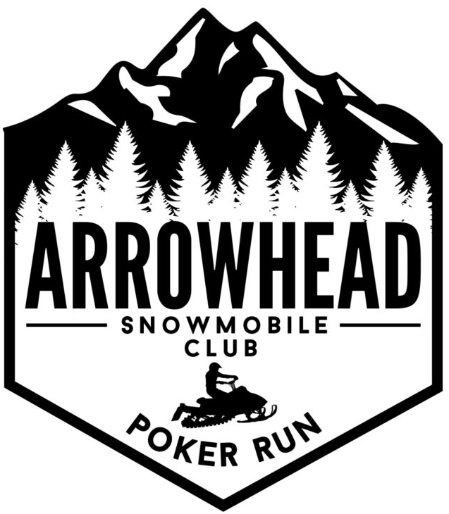
Thank You for your Consideration,

Arrowhead Snowmobile Club

Arrowheadsnowmobile@gmail.com

